**CREATING SERIXCIXI**SQL Scripts (run in this order)

*) Stored procedures:

- sp_populate_super_station -- OK

- sp_populate_basic_station -- OK

- sp_create_super_station_table --OK

- sp_create_basic_station_table --OK

- sp_process_super_station --OK

- sp_process_basic_station --OK

- sp_process_station –OK

- sp_count_super_staging_table

- sp_count_basic_staging_table

*) Functions

- fn_jd -- OK

- fn_solpos -- OK

- fn_hourangle -- OK

- fn_declination -- OK

- fn_eqtime -- OK

- fn_csi -- OK

*) Main Script: Create_Global_Irradiance_Database.SQL

- Create tbl_station_information and load data (static data for stations) – OK

- Create tbl_staging_super_station – OK

- Create tbl_staging_basic_station – OK

- Create tbl_super_station_401…410 – OK

- Create tbl_basic_station_411…425 – OK

- Create tbl_missing_station_data – OK

- Create tbl_dupliacte_station_data -- OK

- Create tbl_station_process_status – OK

- Create tbl_station_process_history – OK

- Create tbl_station_spurious_data

Python Scripts

- Run single_file_bulk_load.py

Database Architecture

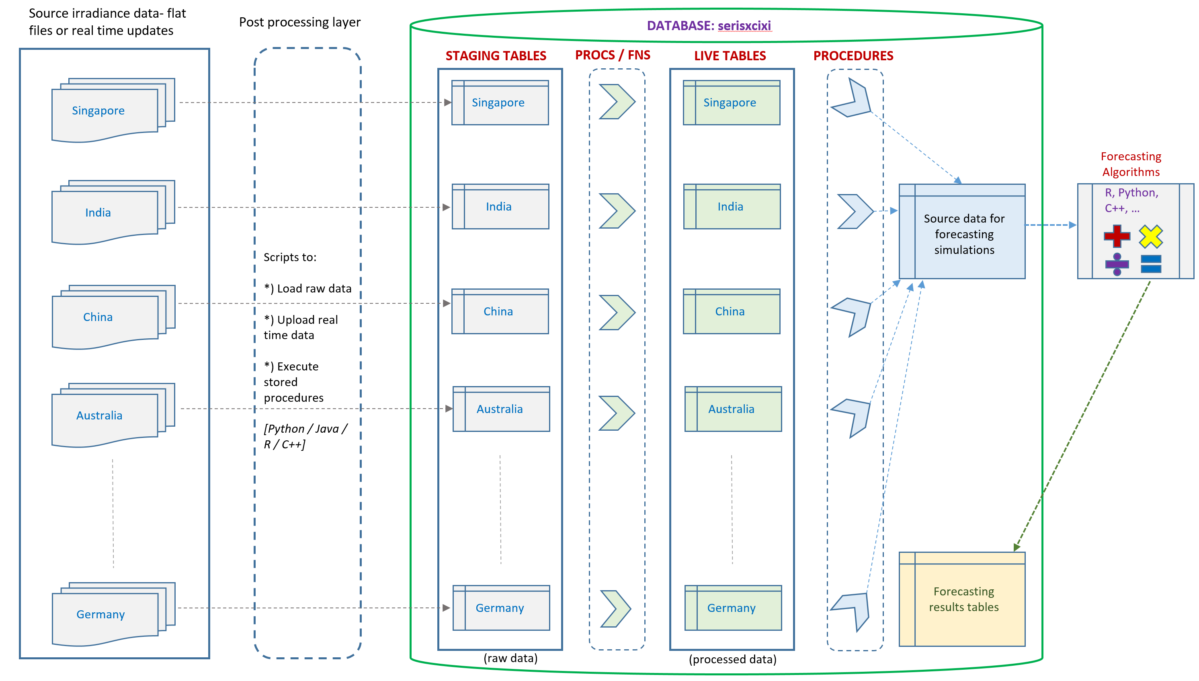

**Staging tables** for raw data

**Live tables** for post-processed data (e.g. fill in missing data, reporting etc.)